**Lab 10: DC Motor Step Response and Position**

650:361 Introduction to Mechatronics

Team Members: Shivani Topiwala, Nancy Contreras, and Pamela Pajarillo

**Introduction**

For this lab, we will use a motor driver in order to investigate motor logic and observe the effects of various types of motor logic schemes and sampling rate on a discrete sensor.

**Part 1: Motor Step Response**

Built model on Simulink given a diagram (on external mode)

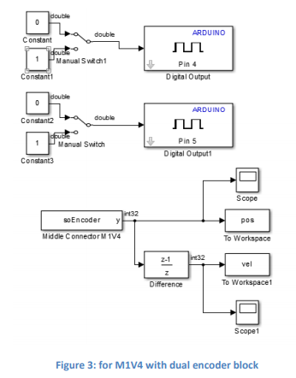

Figure 1: for M1VA with dual encoder block

We ran this Simulink model for a minute. Then, we collected the data on Matlab and plotted the position and velocity data points

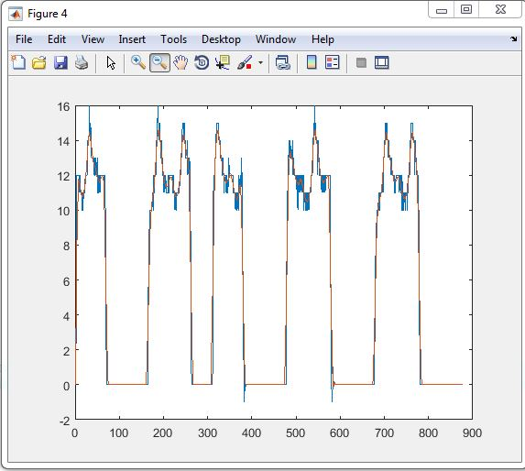

Figure 2: Velocity vs. Time Graph

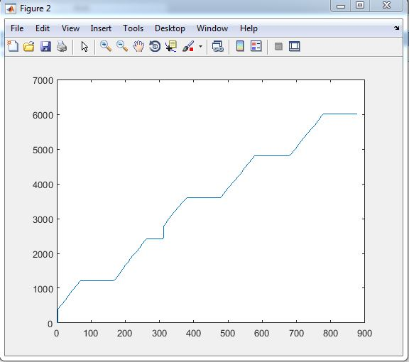

Figure 3: Position vs. Time Graph

Next, to smooth out the data we use the “smooth” command on matlab.

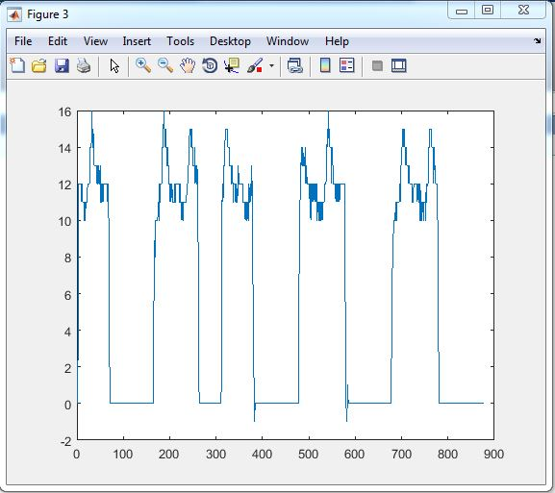

Figure 4: Velocity Graph with smooth out data

**Part 2: Step Response Data from Serial Port**

Built model on Simulink given a diagram

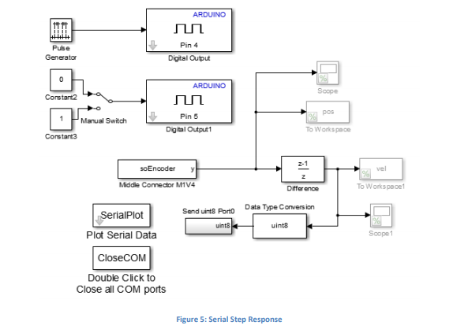

Figure 5: Serial Step Response

On the above diagram, we will comment out the units in gray in order to run the model in normal mode. The complete diagram can be run in external mode.

On External mode: we commented out SerialPlot, CloseCOM, Uint8. When the switch was connected to “0 constant” the data is in the positive y direction. When the switch was connected to “1 constant” the data is in the negative y direction. The SerialPlot block collects data.

CloseCOM ensures that all COM ports Matlab is trying to access is closed.

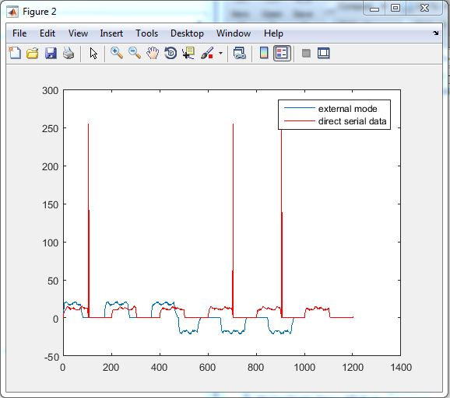

Figure 6: Velocity

Figure 7: Position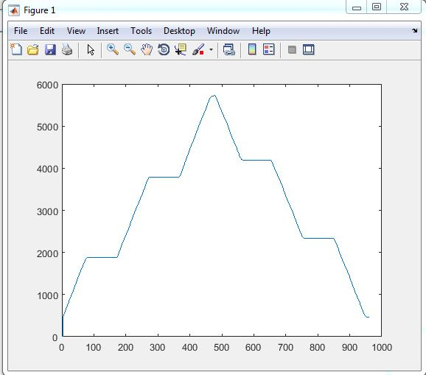

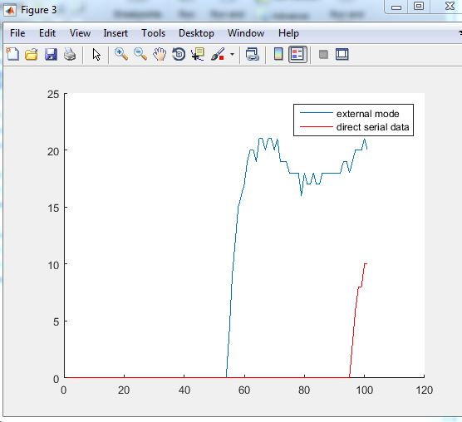

Figure 8: External Mode Data v. Direct Serial Data

**Part 3: Motor Logic: Direction and Magnitude**

In this part, we will use the concept of a PWM signal in order to regulate the speed of the wheels. Using the below diagram, we created a subsystem that followed the magnitude and logic of a PWM signal.

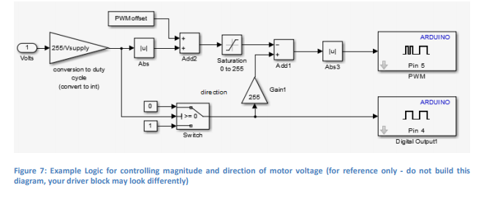

Figure 9: Example Logic for controlling magnitude and direction of motor voltage

We specified the driver supply voltage as 4.5 V, the PWM offset as zero, and set the parameters of the sine wave as a magnitude of 4.5 volts and a period of 3 seconds.

Part 4)

For this part of the lab, our equipment didn’t work properly, so we will be using data provided by a labmate.

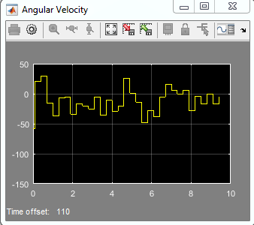

Figure 10: Angular Velocity

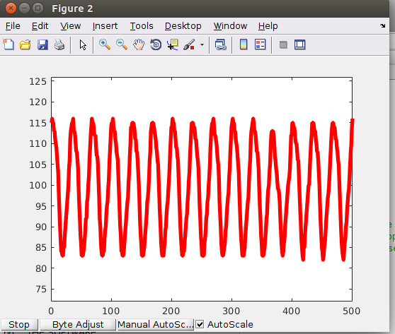

Figure 11

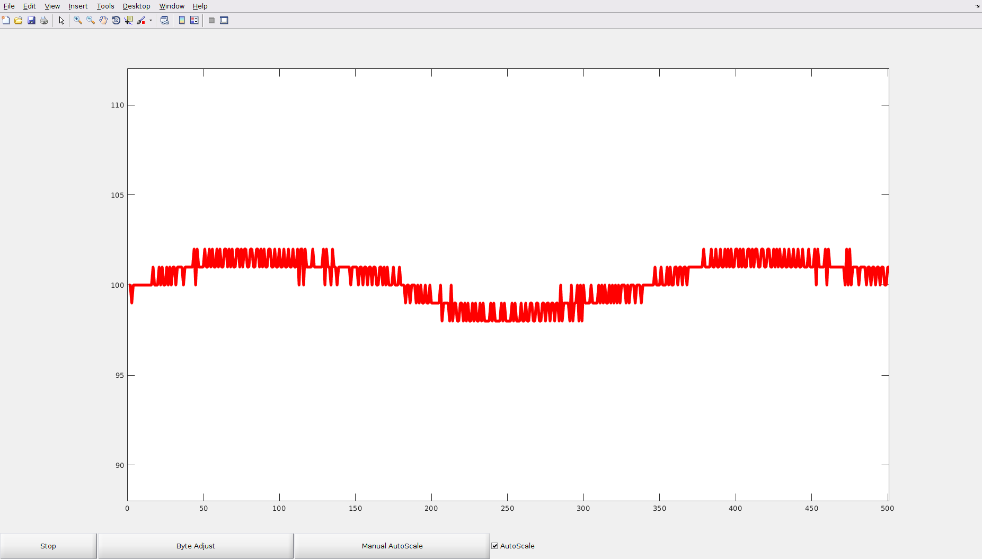

**Conclusion**

In this lab, we were able to investigate different types of logic schemes in order to use a motor drive.